**PaNOSC**

**Photon and Neutron Open Science Cloud**

**H2020-INFRAEOSC-04-2018**

**Grant Agreement Number: 823852**

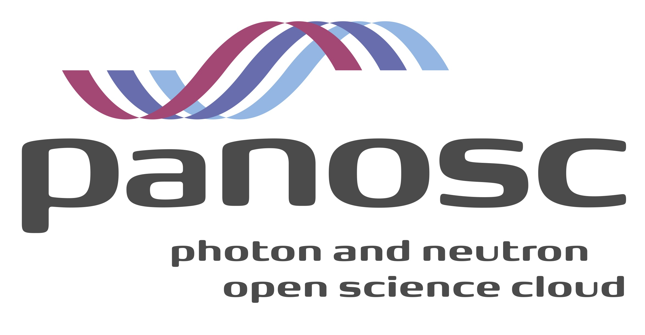

**Deliverable: 7.1 Photon and Neutron EOSC Stakeholder Feedbacks**

# Project Deliverable Information Sheet

|  |  |
| --- | --- |
| Project Reference No. | 823852 |
| Project acronym: | PaNOSC |
| Project full name: | Photon and Neutron Open Science Cloud |
| H2020 Call: | INFRAEOSC-04-2018 |
| Project Coordinator | Andy Götz (andy.gotz@esrf.fr) |
| Coordinating Organization: | ESRF |
| Project Website: | www.panosc.eu |
| Deliverable No: | D7.1 |
| Deliverable Type: | R |
| Dissemination Level | PU |
| Contractual Delivery Date: | M18 |
| Actual Delivery Date: | M16 |
| EC project Officer: |  |

## Document Control Sheet

|  |  |
| --- | --- |
| **Document** | Title: Photon and Neutron EOSC Stakeholder Feedbacks |
| Version:1 |
| Available at: |
| Files: |
| **Authorship** | Written by: R.Pugliese |
| Contributors: O. De Giacomo, D. Roccella |
| Reviewed by: G.Kourousias |
| Approved: |

## List of participants

|  |  |  |
| --- | --- | --- |
| **Participant No.** | **Participant organisation name** | **Country** |
| 1 | European Synchrotron Radiation Facility (ESRF) | France |
| 2 | Institut Laue-Langevin (ILL) | France |
| 3 | European XFEL (XFEL.EU) | Germany |
| 4 | The European Spallation Source (ESS) | Sweden |
| 5 | Extreme Light Infrastructure Delivery Consortium (ELI-DC) | Belgium |
| 6 | Central European Research Infrastructure Consortium (CERIC-ERIC) | Italy |
| 7 | EGI Foundation (EGI.eu) | The Netherlands |

# Table of Content

Project Deliverable Information Sheet 2

Document Control Sheet 2

List of participants 2

Table of Content 3

Introduction 4

Approach and Methodology 4

Draft Stakeholder Types 4

Draft Stakeholder List 5

Questionnaire (For Project Partners and Observers) 8

The stakeholder database 9

Stakeholder types 9

Stakeholder list 10

Stakeholder Feeback 12

Feedback Collection Tools 13

References 14

# Introduction

This report will include the list or database of stakeholders for the Photon and Neutron Open Science Cloud community. The list or database of stakeholders is mandatory for the creation of links with the main players of the EOSC-hub, to the RDA, PaNdata community, ERF Data working group, and relevant industries. We need to create this links in order to be able to collect input and feedback from the stakeholders. The stakeholders will be involved in surveys during project execution in order to collect their important feedback. The stakeholder list is an evidence-based scoping document describing relevant PaNOSC stakeholders. The document describes the methodology used to build the database, contains a presentation of the main types of stakeholders, a preliminary list of them and a questionnaire to collect feedback from partners and observers. The final part includes a description of the features of the survey tool that we will use to collect the feedback from the stakeholders and a summary of the specific feedback that we have planned to ask to the stakeholders.

# Approach and Methodology

In January 2017 a European Project started with the goal to support the development of the first phase of the European Open Science Cloud (EOSC[1]).

The EOSC is supposed to provide a comprehensive and evolving set of services supporting an “open science”-friendly knowledge production lifecycle. The EOSC services shall allow stimulating the research process by the deposition and preservation of data, which can be discovered, accessed, used and reused.

The EU funded PaNOSC project started at the end of 2018 and is helping to align the efforts of the existing and new Photon and Neutron analytical facilities to link up to the EOSC.

To reach the right audience, the stakeholder list of EOSCpilot[2] has been analyzed. From this analysis process a list of stakeholder types has been defined and then a list of stakeholders for the different types. A questionnaire has been then setup and circulated among the different partners and observers to improve both of them. In the following chapters the initial stakeholder types, the stakeholder list, the questionnaire outcomes and the final database is presented.

# Draft Stakeholder Types

PaNOSC will provide petabytes of curated data from thousands of applied and basic science experiments annually and the analysis software for many fields ranging from materials and life sciences to cultural heritage and paleontology. For this reason, every participant or supporting entity of the EOSC and PaN community could be considered as a stakeholder. In the following lines we will list the principal types of stakeholders in order to promote an efficient implementation of the future PaNOSC sustainability plan.

**Data/Research Initiatives**

There are a variety of organizations and initiatives, e.g., GO FAIR[3], FORCE 11[4], OpenAIRE[5], which constitute already organized research communities with specific stakes in policy validation and FAIR principles.

**Cloud providers**

Public and private cloud service providers are by definition critical stakeholders in PaNOSC. Engaging major companies, e.g., Amazon, Google, Microsoft and others, that provide services to a wide range of research activities is essential for bringing together the needs of the research communities and the offered services, and to address some Data privacy issues.

**Research funding organisations**

Funding bodies both on national and EU level are major stakeholders in PaNOSC, since they support research in all its stages. Despite their different organizational schemes in different countries, PaNOSC needs to actively engage them in supporting the future direction of EU cloud infrastructures.

**Other clusters and multi facility partners (CERIC-ERIC & ELI)**

All research entities working with open data, cloud technologies and FAIR data principle are valuable allies in designing the framework for cloud services in the EU. Identifying key players in this sector is a significant challenge.

**Users, Research Communities and Institutions**

Researchers, Research Communities and Research Institutions as main consumers of cloud services are a primary pillar in PaNOSC, since they define the consumer side of the cloud ecosystem. This is a broad class of consumers and identifying the key contact points and the right organization scheme to engage them is a complex task.

**European projects, including Research Infrastructures projects (RIs)**

The Research Infrastructure cluster projects of the EC complement the existing EU infrastructure landscape, by providing thematic (vertical) infrastructures in contrast to the horizontal e-infrastructure. RIs are the key starting point for engaging communities since they are already organized in an operational structure, have a large scientific user base and use or provide cloud services.

**e-Infrastructures**

e-Infrastructures foster the emergence of Open Science, i.e. new working methods based on the shared use of ICT tools and resources across different disciplines and technology domains as well as sharing of results and an open way of working together. Furthermore, e-Infrastructures enable and support the circulation of knowledge in Europe and therefore constitute an essential building block for the European Research Area (ERA).

**Policy makers**

Policy makers affect cloud infrastructures in profound ways, even when they do not act as funders. For example, regulatory bodies on data privacy, on competition and of course on research can shape the future of the cloud ecosystem in the EU. PaNOSC has to identify the most closely related ones and investigate the best way how to engage them.

**Publishers**

Every scientific article published in a journal is related to a set of raw data, metadata and results. The publishers could be PaNOSC stakeholders because it’s in their interest that the dataset related to a specific article is Findable, Accessible, Interoperable, Reusable (FAIR principle).

# Draft Stakeholder List

**European Commission**

The European Commission is the executive of the European Union and promotes its general interest. Following a major effort by the European Commission, the Member States and the scientific community, the European Open Science Cloud (EOSC) was launched to provide a safe environment for researchers to store, analyse and re-use data for research, innovation and educational purposes. The European Open Science Cloud is intended to set off the ground by federating existing scientific data infrastructures that are now spread across disciplines and EU member states. This will make access to scientific data easier and more efficient. The EOSC is projected to become a reality by 2020 and will be Europe’s virtual environment for all researchers to store, manage, analyze and re-use data for research, innovation and educational purposes.

**EOSC Governance entities**

The EOSC is governed by three constituent bodies, as defined by the “European Commission Staff Working Document Implementation Roadmap” for the EOSC. They are:

* The Executive Board, a body tasked to ensure implementation and accountability,
* The EOSC Board, gathering representatives from the Member States and the Commission to ensure effective supervision of the implementation, and
* The Stakeholders Forum, a group of representatives from a wider range of actors, tasked to provide input and recommendations.

These three bodies are intended to be supported by the EOSCsecretariat, another EU funded project under the EOSC umbrella.

PaNOSC and the other ESFRI cluster projects will have to interact with the EOSC governance as they go along implementing FAIR data management.

**EOSC-hub**

EOSC-hub brings together multiple service providers to create the Hub. The EOSC-hub is intended to be a single contact point for European researchers and innovators to discover, access, use and reuse a broad spectrum of resources for advanced data-driven research. For researchers, this will mean a broader access to services supporting their scientific discovery and collaboration across disciplinary and geographical boundaries.

The EOSC, with the two projects EOSC pilot (supporting the first phase) and EOSC-hub (create the integration and service management structure of the EOSC), will be strictly related with the goal of PaNOSC.

**EGI Foundation**

EGI is a federated e-Infrastructure set up to provide advanced computing services for research and innovation using grid computing techniques. This e-Infrastructure creates and delivers open solutions for science and research infrastructures by federating digital capabilities, resources and expertise between communities and across national boundaries. Researchers from all disciplines have easy, integrated and open access to the advanced scientific computing capabilities, resources and expertise needed to collaborate and to carry out data/compute intensive science and innovation. In this sense we can consider EGI as a stakeholder but also as a shareholder and a project partner.

**Project Partners**

Every Project Partner of PaNOSC (ESRF, ILL, EU-XFEL, ESS, ELI-DC, CERIC-ERIC and EGI) is by definition a stakeholder of the project. In particular to develop an efficient sustainability plan, the outcomes of every work package needs to be taken into account.

**PaN Community**

Photon and Neutron Community was the first working group implementing a data policy (EU funded PaNData project), standard formats (NEXUS), user authentication (Umbrella) and catalog (ICAT). This community can contribute in terms of best practices and is a major stakeholder. The PaN scientific user community needs to be involved in the project to provide timely feedback on the project deliverables. The addition to PaNOSC, the national Photon and Neutron laboratories are working together in the ExPaNDS project which pursues similar, if not identical, goals than PaNOSC. Close interaction with ExPaNDS is necessary. Another strong link with the PaN community will be through the LEAPS and LENS consortia which aim to bring their research infrastructures together for technical and scientific developments requiring a concerted effort.

**ESFRI cluster projects**

The H2020 projects ENVRI, EOSC-LIFE, ESCAPE, and SSHOC have similar goals and it is necessary to keep a close relationship with their project managements to align as much as possible goals and deliverables.

**PRACE Partnership**

The mission of PRACE[6] (Partnership for Advanced Computing in Europe) is to enable high-impact scientific discovery and engineering research and development across all disciplines to enhance European competitiveness for the benefit of society. PRACE seeks to realise this mission by offering world class computing and data management resources and services through a peer review process.

PRACE could become a stakeholder in the PaNOSC endeavour if the PRACE business model is able to adapt to the needs of our scientific community by providing on demand services complementing their current peer review access to PRACE resources.

**RDA**[8]

The Research Data Alliance (RDA) is a research community organisation for open sharing of data across technologies, disciplines, and countries to address the grand challenges of society. The RDA is a major recipient of support in the form of grants from its constituent members’ governments. The RDA’s main vehicle for outputs are 18-month long working groups that generate recommendations aimed at the RDA community. In addition interest groups with no fixed lifetime can produce informal or supported outputs which carry some degree of RDA endorsement.

It remains to be seen how the work in PaNOSC can be promoted in/by RDA and whether RDA recommendations can be applied within PaNOSC.

In addition the above stakeholder list, other parties that can be considered stakeholders are:

* GO FAIR[9]
* FORCE 11[10]
* OpenAIRE
* FAIRsFAIR
* EUDAT
* Industry

# Questionnaire (For Project Partners and Observers)

After an internal discussion the project team has defined the following survey that has been submitted to the project partners and observers. Here is the online form that was used to collect feedback and update the stakeholder database.

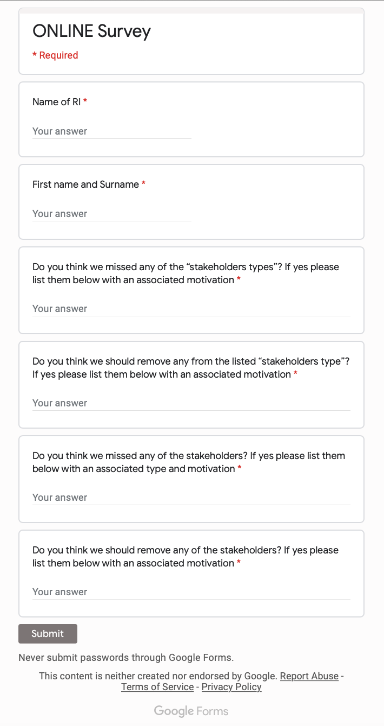

# The stakeholder database

In the following pages it is reported the current status of the stakeholder database, which is based on the refined draft and takes into account the feedback provided by partners and observers. The database is available as a shared spreadsheet on the cloud so that it can be kept constantly up-to-date and is available to all the project partners. The database is divided in two parts: the stakeholder **types** and the stakeholder **list**.

## Stakeholder types

Below you can find the list of stakeholder types for PaNOSC community.

|  |  |
| --- | --- |
| **Name** | **Description** |
| Data/Research Initiatives | There are a variety of organizations and initiatives, e.g., GO FAIR, FORCE 11, OpenAIRE, which constitute already organized research communities with specific stakes in policy validation and FAIR principles. |
| Cloud providers | Public and private cloud service providers are by definition critical stakeholders in PaNOSC. Engaging major companies, e.g., Amazon, Google, Microsoft, Oracle and others, that provide services to a wide range of research activities is essential for bringing together the needs of the research communities and the offered services, and to address some Data privacy issues. |
| Research funding organisations | Funding bodies both on national and EU level are major stakeholders in PaNOSC, since they support research in all its stages. Despite their different organizational schemes in different countries, PaNOSC needs to actively engage them in supporting the future direction of EU cloud infrastructures. |
| Other clusters and multi facility partners (CERIC-ERIC & ELI) | All research entities working with open data, cloud technologies and FAIR data principles are valuable allies in designing the framework for cloud services in the EU. Identifying key players in this sector is a significant challenge. |
| Users, Research Communities and Institutions | Researchers, Research Communities, Research Institutions and Consortia as main consumers of cloud services are a primary pillar in PaNOSC, since they define the consumer side of the cloud ecosystem. This is a broad class of consumers and identifying the key contact points and the right organization scheme to engage them is a complex task. |
| Other European projects related to the EOSC | The projects funded by EC related to the EOSC are potential stakeholders as it may be worth to share ideas to implement services and tools thus avoiding re-inventing the wheel in order to speed up the EOSC construction. Other cluster projects of national facilities that are mirroring the ESFRI clusters like ExPANDS for instance, belong to this type. |
| European Research Infrastructures (ERIs) | The European Research Infrastructures, cluster projects of the EC and European Research Infrastructure Consortiums (ERICs) and other network of facilities complement the existing EU infrastructure landscape, by providing thematic (vertical) infrastructures in contrast to the horizontal e-infrastructure. RIs are the key starting point for engaging communities since they are already organized in an operational structure, have a large scientific user base and use or provide cloud services. |
| National Research Infrastructures (NRIs) | The National Research Infrastructures complement the existing EU infrastructure landscape as even if funded by the single nations, provide services to researchers coming from Europe and extra-European countries. The data produced by these infrastructures should follow the same FAIR principles. |
| Non-European Research Infrastructures (NERIs) | European photon and neutron sources share users and technology with non-European ones. Example of such infrastructures are SNS, JPARC, etc. |
| e-infrastructures | e-Infrastructures foster the emergence of Open Science, i.e. new working methods based on the shared use of ICT tools and resources across different disciplines and technology domains as well as sharing of results and an open way of working together. Furthermore, e-Infrastructures enable and support the circulation of knowledge in Europe and therefore constitute an essential building block for the European Research Area (ERA). |
| RIs shareholders and funding bodies | All RIs shareholders and funding bodies are potential stakeholders of PaNOSC as at the end they fund the Research Infrastructures operations and their engagement is key to the sustainability of the EOSC in the long term. |
| Policy makers | Policy makers affect cloud infrastructures in profound ways, even when they do not act as funders. For example, regulatory bodies on data privacy, on competition and of course on research can shape the future of the cloud ecosystem in the EU. PaNOSC has to identify the most closely related ones and investigate the best way how to engage them. |
| Publishers | Every scientific article published in a journal is related to a set of raw data, metadata and results. The publishers could be PaNOSC stakeholders because it’s also in their interest that the dataset related to a specific article is Findable, Accessible, Interoperable, Reusable (FAIR principle). |
| ICT Industry, Industry associations and technology providers | Industry and commercial providers will be interested in providing cloud services but also to develop technologies and experiment systems to support the EOSC that may have then an economic value. Working on the EOSC may be an example of open innovation. |

## Stakeholder list

Below you can find the list of stakeholders for PaNOSC community. The database is a live document and will be updated during the project life span.

|  |  |  |  |
| --- | --- | --- | --- |
| Name | Type | Description | Contact points |
| European Commission | Users, Research Communities and Institutions | The European Commission is the executive of the European Union and promotes its general interest. Following a major effort by the European Commission, the Member States and the scientific community, the European Open Science Cloud (EOSC) was launched to provide a safe environment for researchers to store, analyse and re-use data for research, innovation and educational purposes. The European Open Science Cloud is intended to set off the ground by federating existing scientific data infrastructures that are now spread across disciplines and EU member states. This will make access to scientific data easier and more efficient. The EOSC is projected to become a reality by 2020 and will be Europe’s virtual environment for all researchers to store, manage, analyze and re-use data for research, innovation and educational purposes. | <https://ec.europa.eu/transparency/regexpert/index.cfm?do=groupDetail.groupDetail&groupID=3485&NewSearch=1&NewSearch=1&Lang=EN>  PaNOSC project officer: Rene Martins - rene.martins@ec.europa.eu |
| EOSC Governance entities | Users, Research Communities and Institutions | The EOSC is governed by three constituent bodies, as defined by the “European Commission Staff Working Document Implementation Roadmap” for the EOSC. They are: The Executive Board, a body tasked to ensure implementation and accountability, The EOSC Board, gathering representatives from the Member States and the Commission to ensure effective supervision of the implementation, and The Stakeholders Forum, a group of representatives from a wider range of actors, tasked to provide input and recommendations. These three bodies are intended to be supported by the EOSCsecretariat, another EU funded project under the EOSC umbrella.  PaNOSC and the other ESFRI cluster projects will have to interact with the EOSC governance as they go along implementing FAIR data management. | [Rupert Lueck, Sustainability WG co-chair, EMBL (European Molecular Biology Laboratory) Representative: rupert.lueck@embl.de  Prof. Giorgio Rossi, Italian representative for the Governance Board of the EOSC: giorgio.rossi@nffa.eu](http://lastatalenews.unimi.it/giorgio-rossi-governing-board-eosc) |
| EOSC-hub | Other European projects related to the EOSC | EOSC-hub brings together multiple service providers to create the Hub. The EOSC-hub is intended to be a single contact point for European researchers and innovators to discover, access, use and reuse a broad spectrum of resources for advanced data-driven research. For researchers, this will mean a broader access to services supporting their scientific discovery and collaboration across disciplinary and geographical boundaries.  The EOSC, with the two projects EOSC pilot (supporting the first phase) and EOSC-hub (create the integration and service management structure of the EOSC), will be strictly related with the goal of PaNOSC. | Tiziana Ferrari, Technical Director: tiziana.ferrari@egi.eu |
| EGI Foundation | e-infrastructures | EGI is a federated e-Infrastructure set up to provide advanced computing services for research and innovation using grid computing techniques. This e-Infrastructure creates and delivers open solutions for science and research infrastructures by federating digital capabilities, resources and expertise between communities and across national boundaries. Researchers from all disciplines have easy, integrated and open access to the advanced scientific computing capabilities, resources and expertise needed to collaborate and to carry out data/compute intensive science and innovation. In this sense we can consider EGI as a stakeholder but also as a shareholder and a project partner. | Tiziana Ferrari, Technical Director: tiziana.ferrari@egi.eu |
| Project Partners | European Research Infrastructures (ERIs) | Every Project Partner of PaNOSC (ESRF, ILL, EU-XFEL, ESS, ELI-DC, CERIC-ERIC and EGI) is by definition a stakeholder of the project. In particular to develop an efficient sustainability plan, the outcomes of every work package needs to be taken into account. | management@panosc.eu, executive@panosc.eu |
| PaN Community | Users, Research Communities and Institutions | The Photon and Neutron Community was the first working group implementing a data policy (EU funded PaNData project), standard formats (NEXUS), user authentication (Umbrella) and catalog (ICAT). This community can contribute in terms of best practices and is a major stakeholder. The PaN scientific user community needs to be involved in the project to provide timely feedback on the project deliverables. In addition to PaNOSC, the national Photon and Neutron laboratories are working together in the ExPaNDS project which pursues similar, if not identical, goals than PaNOSC. Close interaction with ExPaNDS is necessary as well as interaction with other projects like CALIPSOplus that has a reseach activity quite aligned to PaNOSC goals. Another strong link with the PaN community will be through the LEAPS and LENS consortia which aim to bring their research infrastructures together for technical and scientific developments requiring a concerted effort. In the same sense an important stakeholder to be considered is the HERCULES school and other summer schools because they are a channel for spreading the outcome of PaNOSC (http://hercules-school.eu). | ExPANDS Sustainability: patrick.fuhrmann@desy.de ExPANDS Coordinator: sophie.servan@desy.de  LEAPS Project Manager: lucia.scioscia2@unibo.it, julia.hauk@desy.de LEAPS IT: mark.heron@diamond.ac.uk  CALIPSOplus: valentina.piffer@psi.ch  LENS contact point: contact@lens-initiative.org  HERCULES contact: Coordinator - vincent.favre-nicolin@esrf.fr Specialized courses - grenier@ill.fr |
| Users communities | Users, Research Communities and Institutions | The user community and their associations are one of the key types of stakeholders, in particular the European Neutron Scattering Association (ENSA: http://www.neutrons-ensa.eu) and the The European synchrotron and FEL user organisation (ESUO - http://esuo.org) | ESUO: Chair: pietsch@physik.uni-siegen.de  https://ensa.tudelft.nl/about/ Chair, Christiane Alba-Simionesco: christiane.alba-simionesco@cea.fr   http://www.wayforlight.eu/en/users/esuo/ |
| ESFRI cluster project | Other European projects related to the EOSC | The H2020 projects ENVRI, EOSC-LIFE, ESCAPE, and SSHOC have similar goals and it is necessary to keep a close relationship with their project managements to align as much as possible goals and deliverables. | ENVRI-FAIR: Andreas Petzold, FZJ - a.petzold@fz-juelich.de EOSC-LIFE: Andrew Smith, ELIXIR - andrew.smith@elixir-europe.org ESCAPE: Giovanni Lamanna, CNRS - giovanni.lamanna@lapp.in2p3.fr SSHOC: Ron Dekker, CESSDA - ron.dekker@cessda.eu |
| PRACE Partnership | RIs shareholders and funding bodies | The mission of PRACE (Partnership for Advanced Computing in Europe) is to enable high-impact scientific discovery and engineering research and development across all disciplines to enhance European competitiveness for the benefit of society. PRACE seeks to realise this mission by offering world class computing and data management resources and services through a peer review process. PRACE could become a stakeholder in the PaNOSC endeavour if the PRACE business model is able to adapt to the needs of our scientific community by providing on demand services complementing their current peer review access to PRACE resources. | http://www.prace-ri.eu/contact-prace f.berberich@fz-juelich.de |
| RDA | Users, Research Communities and Institutions | The Research Data Alliance (RDA) is a research community organisation for open sharing of data across technologies, disciplines, and countries to address the grand challenges of society. The RDA is a major recipient of support in the form of grants from its constituent members’ governments. The RDA’s main vehicle for outputs are 18-month long working groups that generate recommendations aimed at the RDA community. In addition interest groups with no fixed lifetime can produce informal or supported outputs which carry some degree of RDA endorsement.  It remains to be seen how the work in PaNOSC can be promoted in/by RDA and whether RDA recommendations can be applied within PaNOSC. |  |
| Other european related projects | Other European projects related to the EOSC | EUDAT | info@eudat.eu |
| Data/Research Initiatives | Data/Research Initiatives | GO FAIR  FORCE 11  OpenAIRE  FAIRsFAIR | FAIRsFAIR: Ingrid Dillo - project coordinator - ingrid.dillo@dans.knaw.nl OpenAIRE: Natalia Manola - natalia@di.uoa.gr |
| Research ministries across eu | Research funding organisations | These are typical research funding organisations for national and european level research infrastructures: STFC, CNRS, CEA, CNR, INFN, MIUR, etc. | Spain: Miguel Angel Garcia Aranda France: Maria Faury (CEA), Emmanuelle Lacaze (CNRS) Germany: Martin Thomé (BMBF) Italy: Elisa Molinari (CNR) UK: Grahame Blair (STFC) Laurent Ghys Ingmar Persoon |
| ICT Industry, Industry associations and technology providers | Cloud providers | These will be in direct contact with EGI and PRACE even if we cannot exclude a direct connection with the PaNOSC project partners: Google, Amazon, Microsoft, IBM, etc. An example of technology provider is Jupyter project (http://www.jupyther.org). | Tiziana Ferrari, Technical Director: tiziana.ferrari@egi.eu |

# Stakeholder Feeback

Targeted questionnaires for every category of stakeholder will be developed and the questionnaires will be collected online or used as a base for the interviews.

The feedback from stakeholders will allow us to address the tasks and finalize the other deliverables of the sustainability workpackage.

In particular the deliverable “D7.2: Photon and Neutron EOSC metrics and costs model” will analise and develop metrics for the evaluation of costs and added value of the services provided to the community.

After the development of the first draft metrics and cost model we will considering the feedback from stakeholders. The collected feedback will be used to refine the metric and the cost model in order to produce a final version of the metrics and cost model in November 2021.

The deliverable “D7.3: Photon and Neutron EOSC Business model reference document” will develop advanced business and funding models in connection with Industrial Liaison Offices of each facility, the user communities and all the relevant industrial and research community EOSC stakeholders. After a first draft of the business models we will consult stakeholders via a survey and we will refine it according to stakeholders consultation result. The final version of the business model reference document will be produced on May 2022.

In the same line in deliverable “D7.4: Photon and Neutron EOSC Sustainability plan” we will develop a formal long-term mission and vision for the sustainability of the PaNOSC infrastructure and software developed which will balance the viewpoints of the different stakeholder and the developed business models. After the preparation of a first draft we will launch a consultation with stakeholders and we will develop the final version based on the outcomes of the consultation. The final version of the sustainability plan will be produced on November 2022.

# Feedback Collection Tools

Surveys or survey forms are an efficient way to collect feedback from the PaNOSC stakeholders. Surveys also serve as an engaging factor. It seems reasonable to integrate these tools in the website of the PaNOSC project in order to increase the community engagement. As the PaNOSC website is implemented in WordPress, we have decided to create these surveys and then track the survey execution via a WordPress survey plugin. With the help of a WordPress Survey plugin, you can integrate Surveys and even analyze the data within the plugin.

We have thus searched for a suitable WordPress Survey plugin among the best Survey Plugins available: both Premium and Free. Here is the list of plugins that we have considered:

1. Everest Forms (Premium)
2. **Opinion Stage** (Free) - [the system we chose]
3. WP-Polls (Free)
4. eForm Builder (Premium)
5. GetSiteControl (Free)
6. Modal Survey (Premium)
7. Modal Survey (Premium)
8. Diker (Premium)
9. Reputation Management (Premium)

At the end we have selected Opinion Stage which is free and has options to create forms, surveys, quizzes as well as polls and slideshows. It also allows filtration option for polls according to categories, it permits to view all the details of the poll shares, it has many customization options including the possibility to add personalized forms with the project’s and facilities' logos.

# References

[1] <https://eoscpilot.eu/about/eoscpilot-brief>

[2] <https://eoscpilot.eu/sites/default/files/eoscpilot_d2.7_submitted.pdf>

[3] <https://www.go-fair.org/>

[4] <https://www.force11.org/>

[5] <https://www.openaire.eu/>

[6] <http://www.prace-ri.eu/prace-in-a-few-words/>

[7] <http://www.prace-ri.eu/members/>

[8] <https://rd-alliance.org/>

[9] <https://www.go-fair.org/>

[10] <https://www.force11.org/>